**Jenkins Task-2**

**Task Description:**

Create a simple script file and push it to repo. Create a project in Jenkins connected to your GitHub repository. When a commit is made to your repo, automatically build must get triggered from Jenkins and the output must be shared to me via email.

1. **Created a new repo and pushed to GIT**

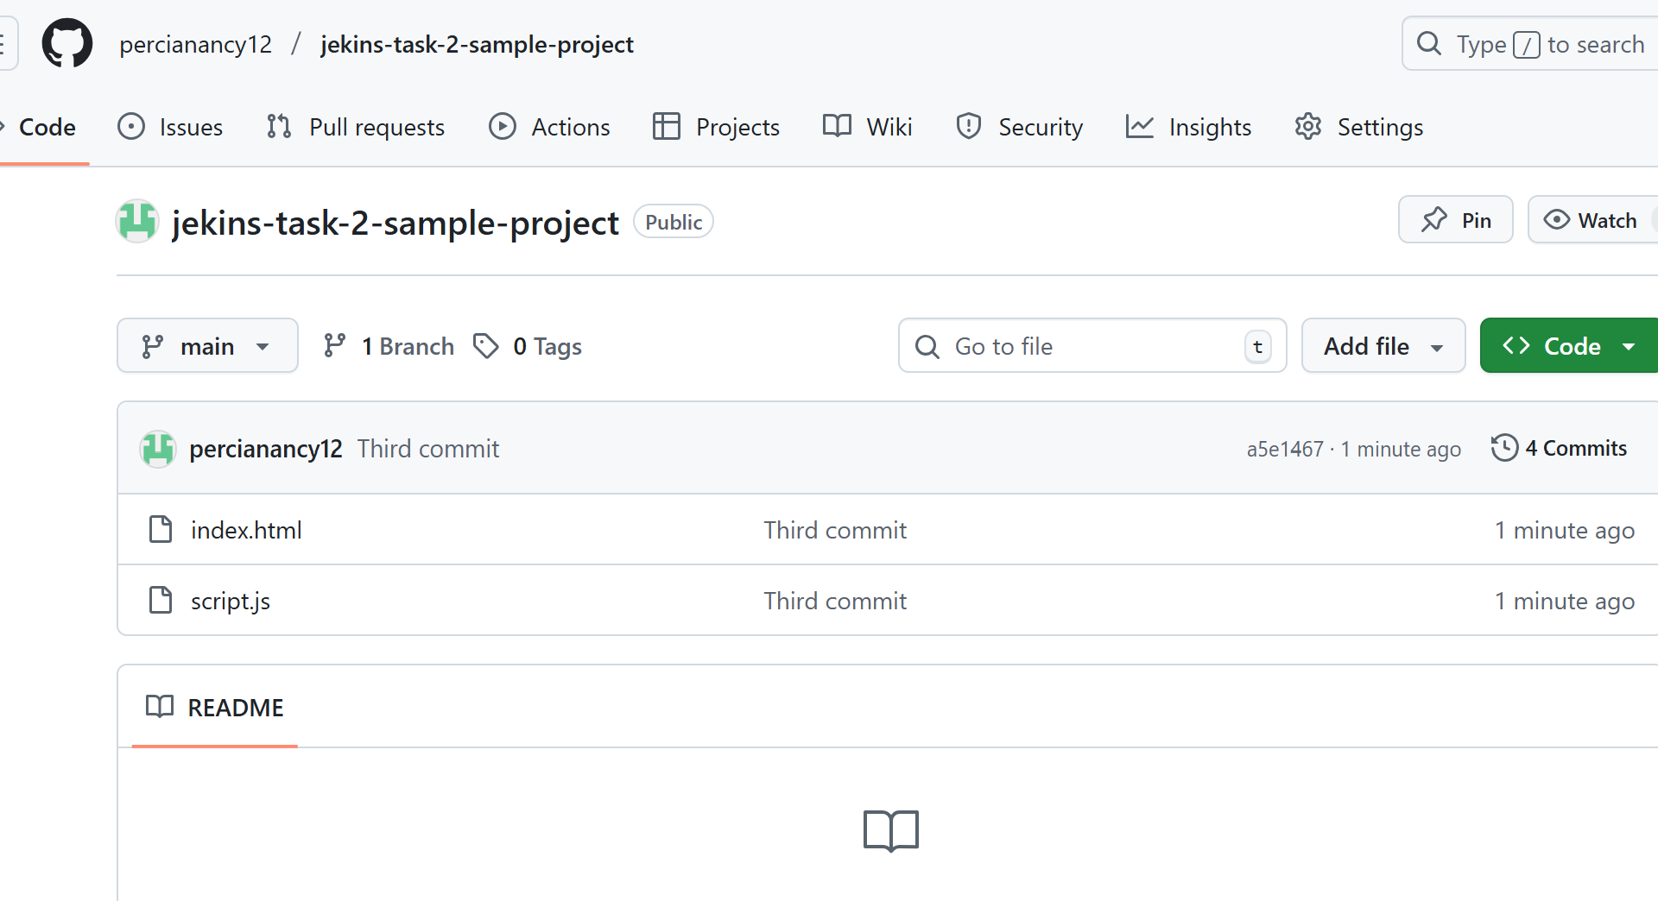

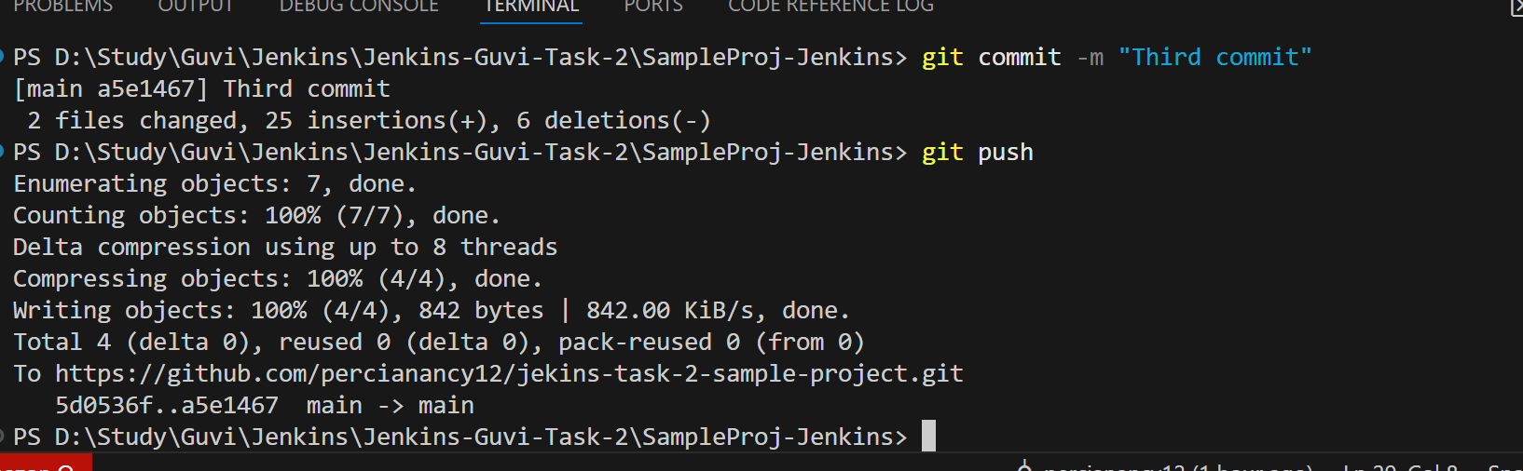

1. **Install Jenkins in EC2 server**

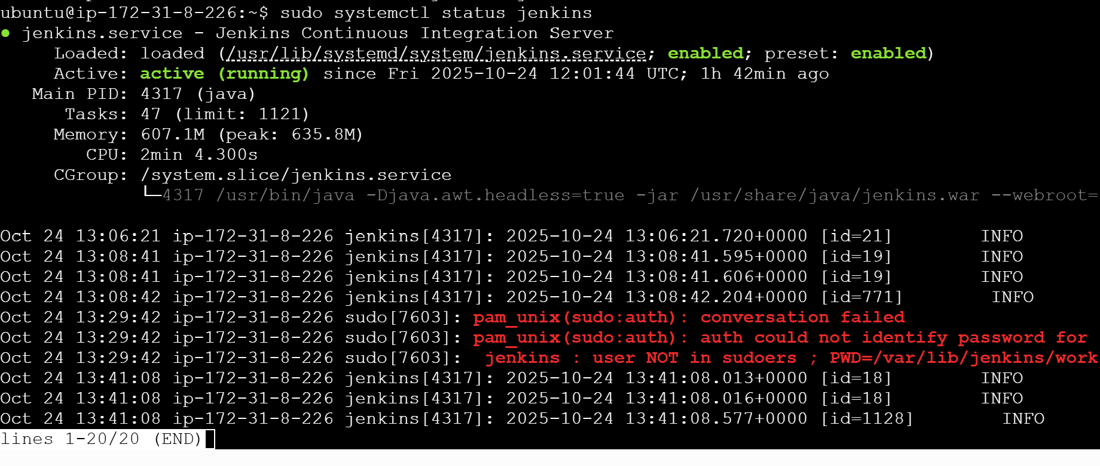

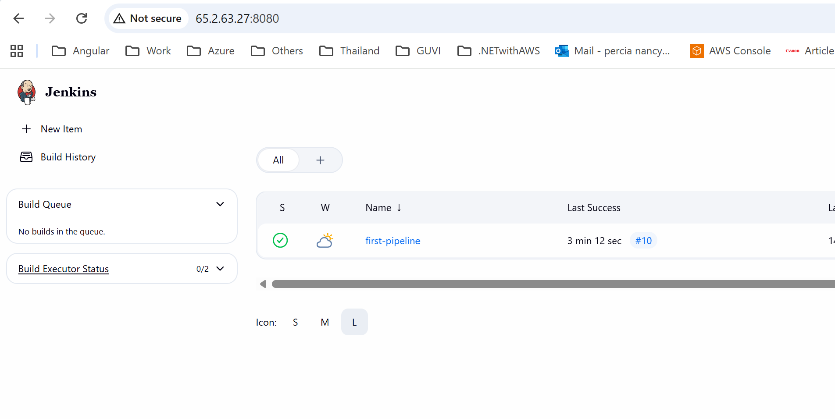

1. **Create a new pipeline**

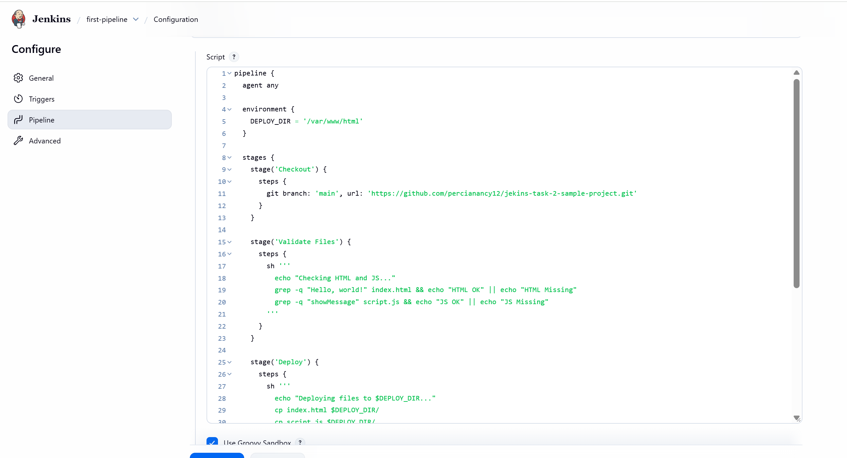

1. **Add the email credential**

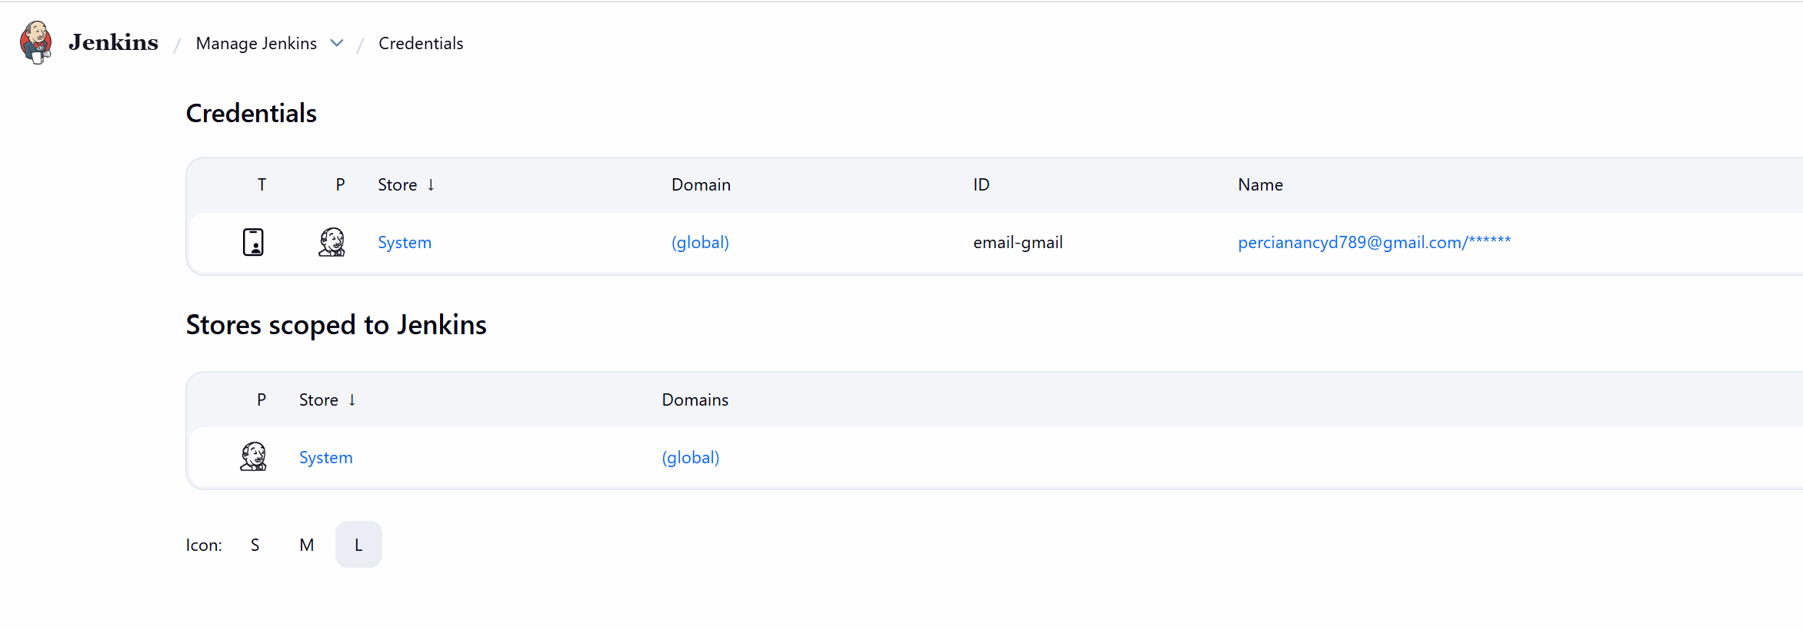

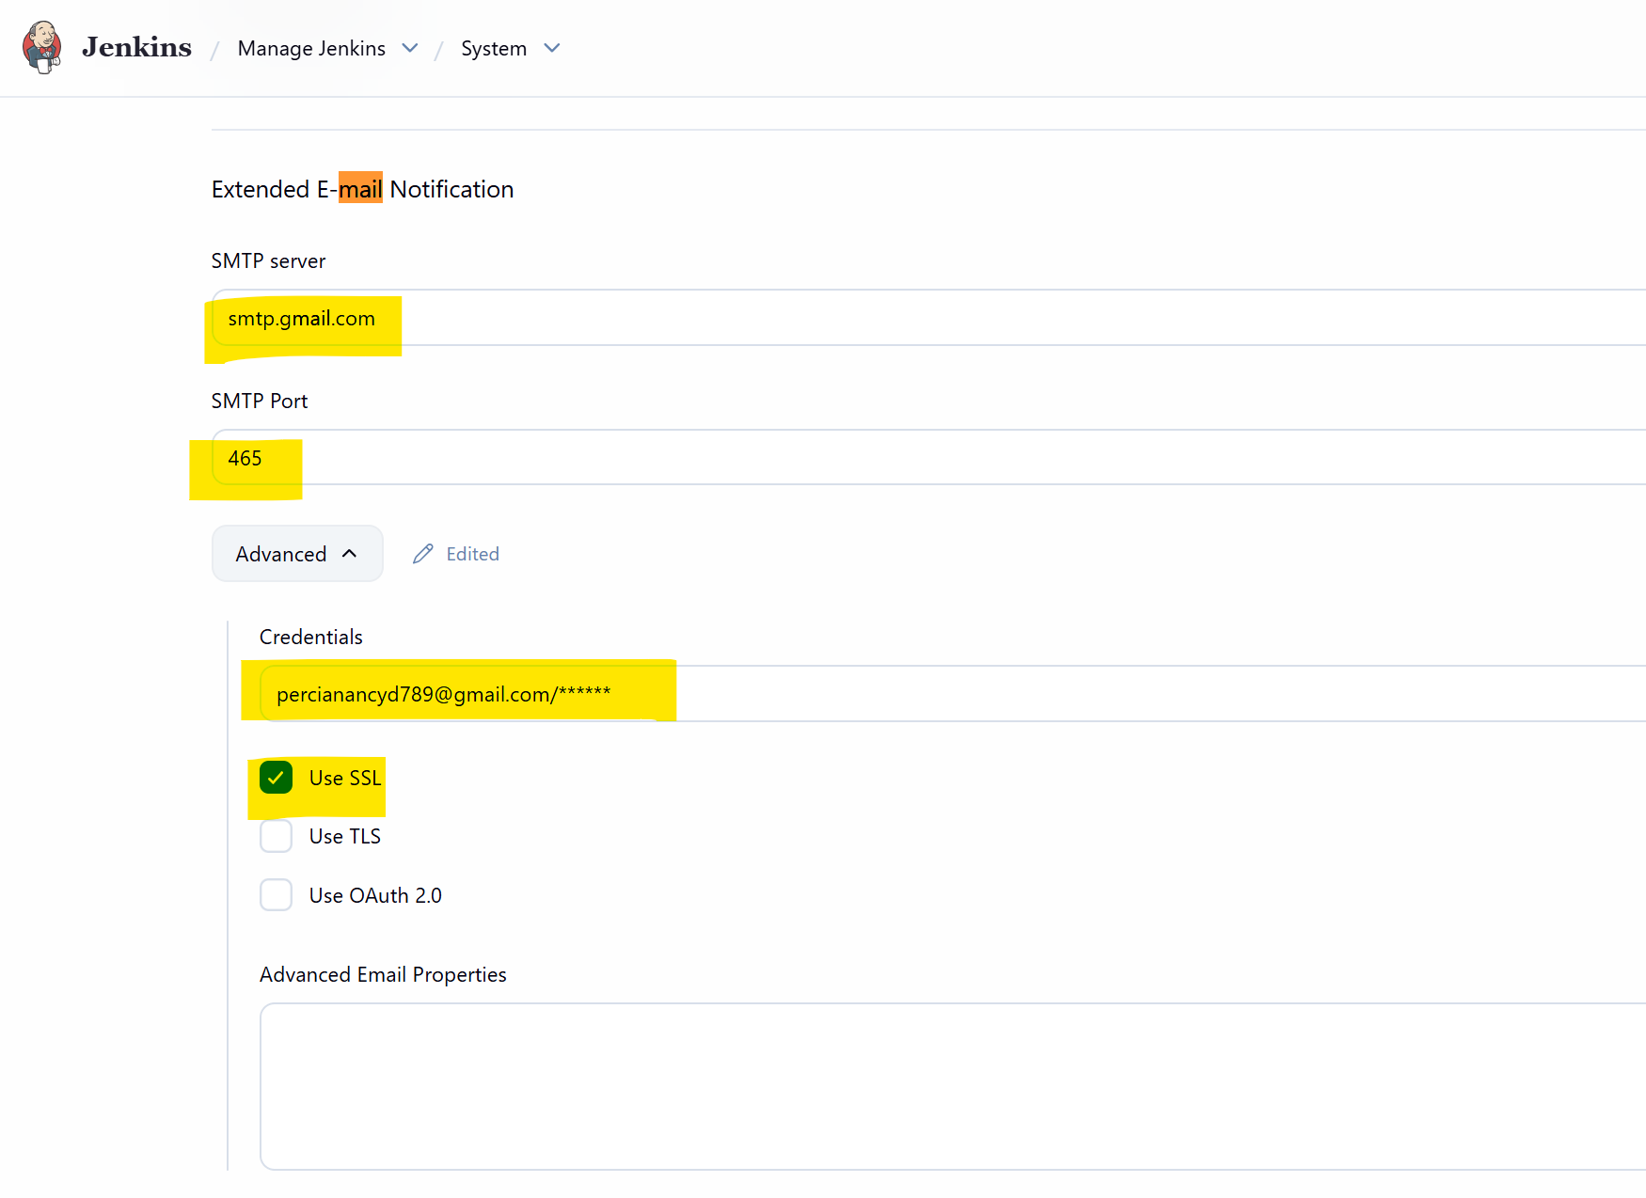

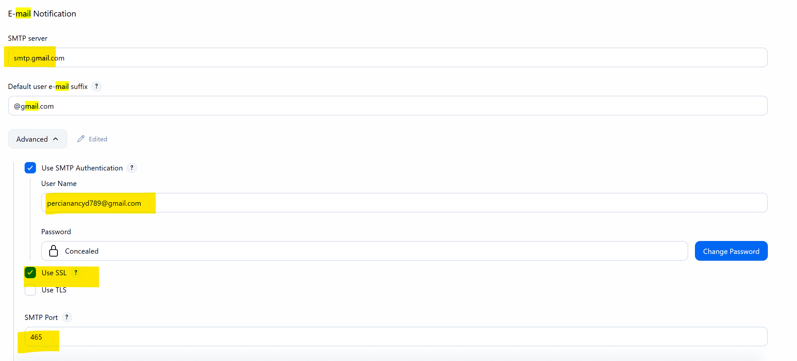

1. **Add Webhook in GIT**

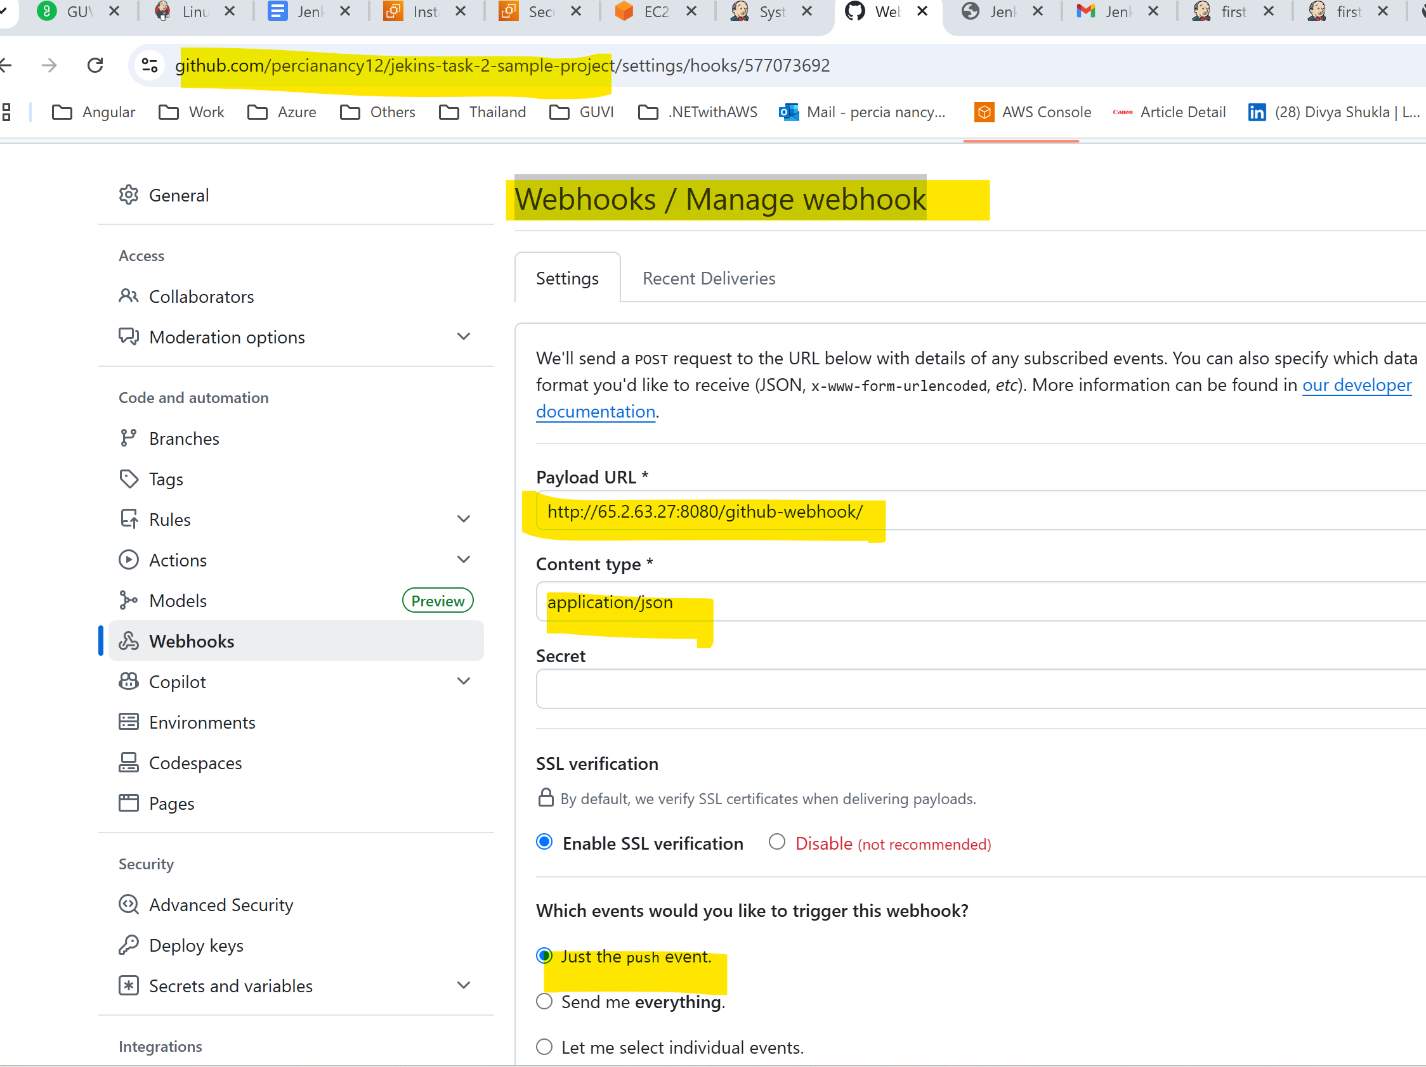

1. **To View the GIT project in EC2 server installing Apache**

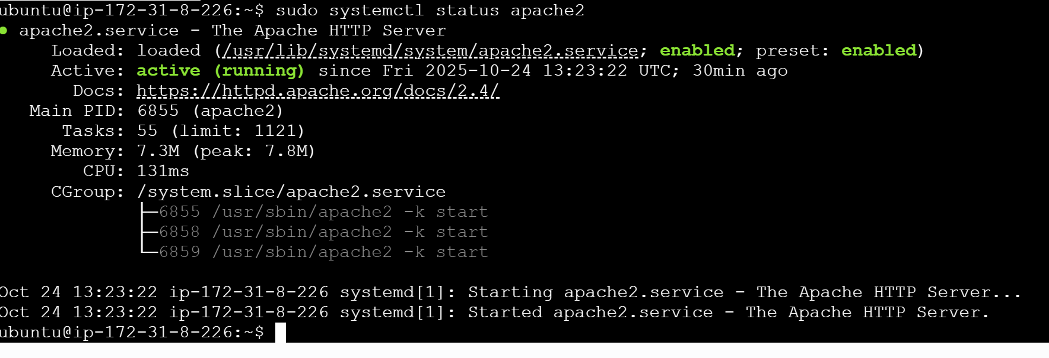

1. **Grant Jenkins Permission to Deploy**

*sudo chown -R jenkins:jenkins /var/www/html*

1. **Once the code pushed to GitHub built triggered automatically**

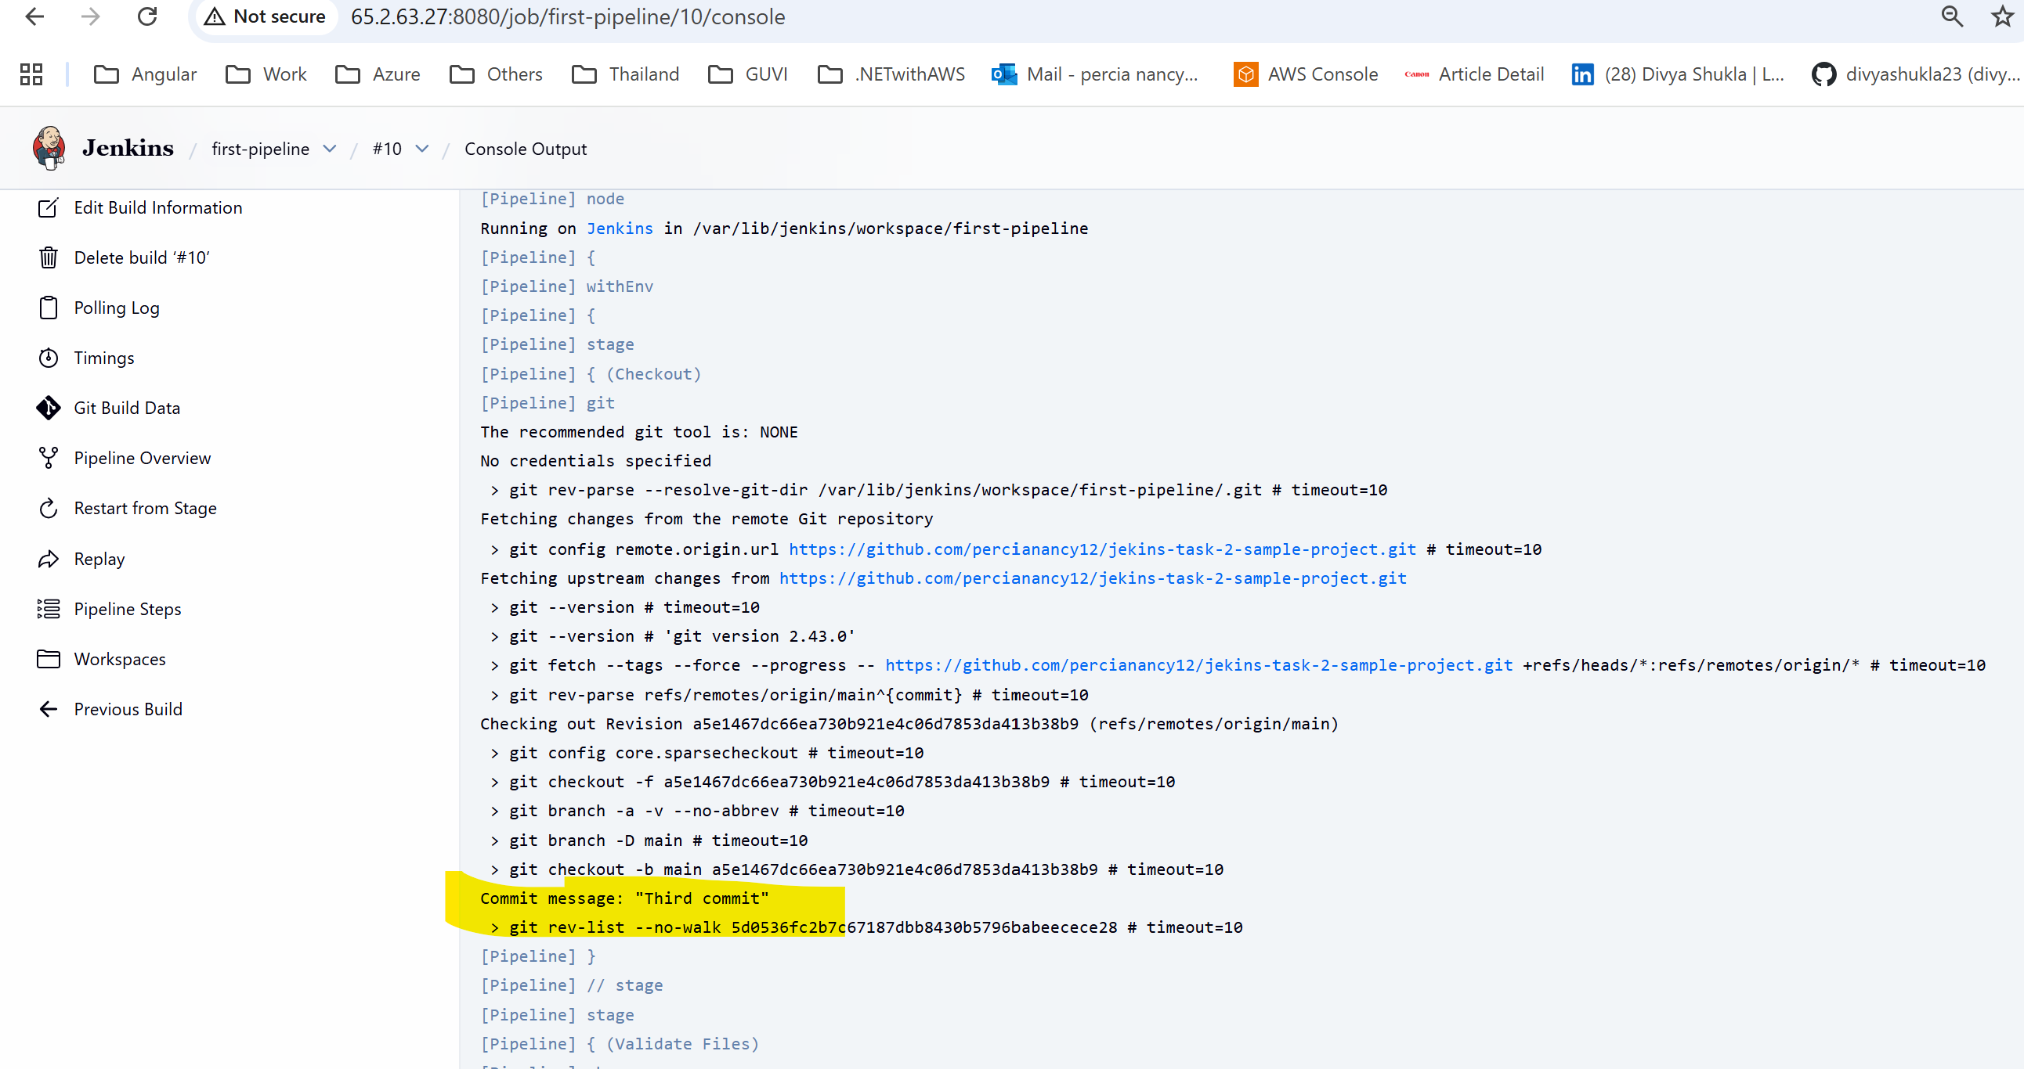

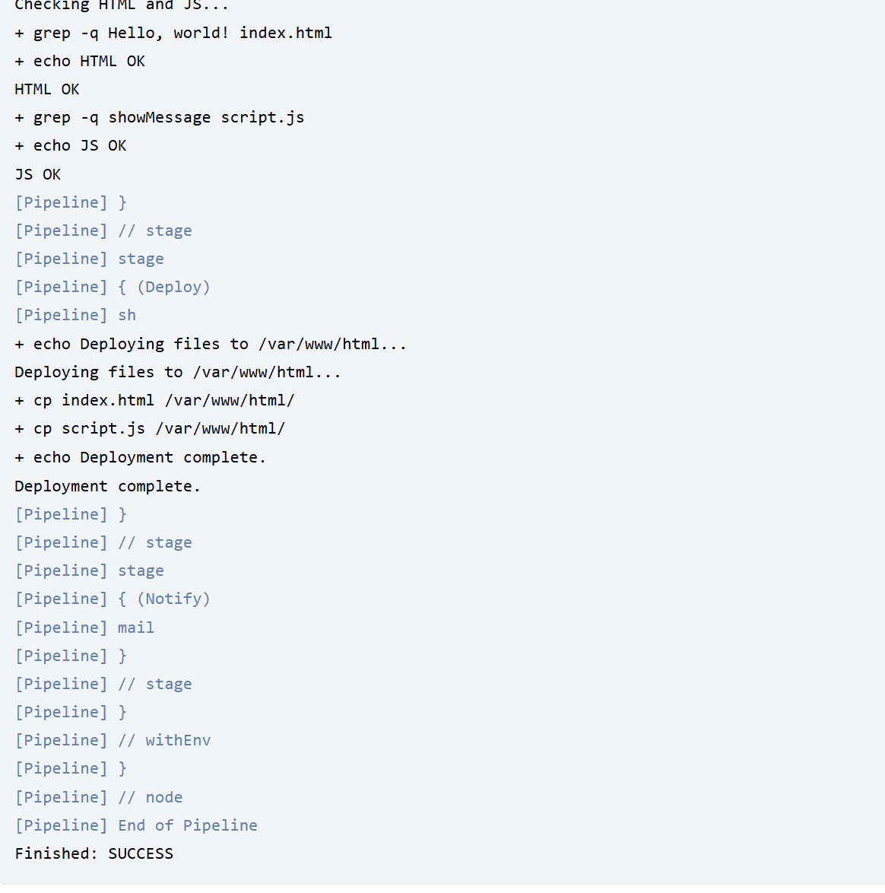

1. **Email triggered**

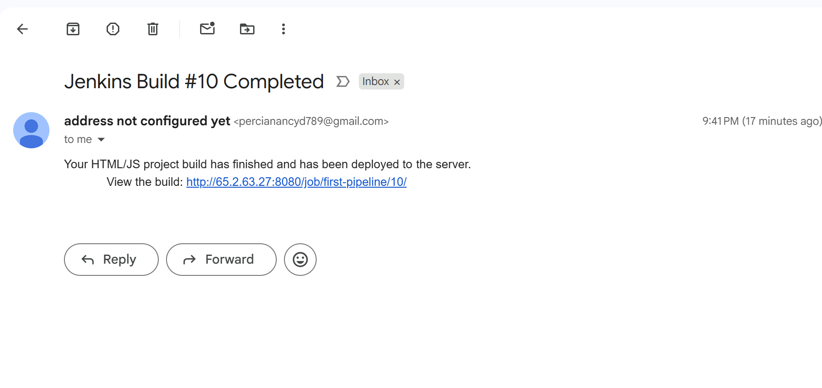

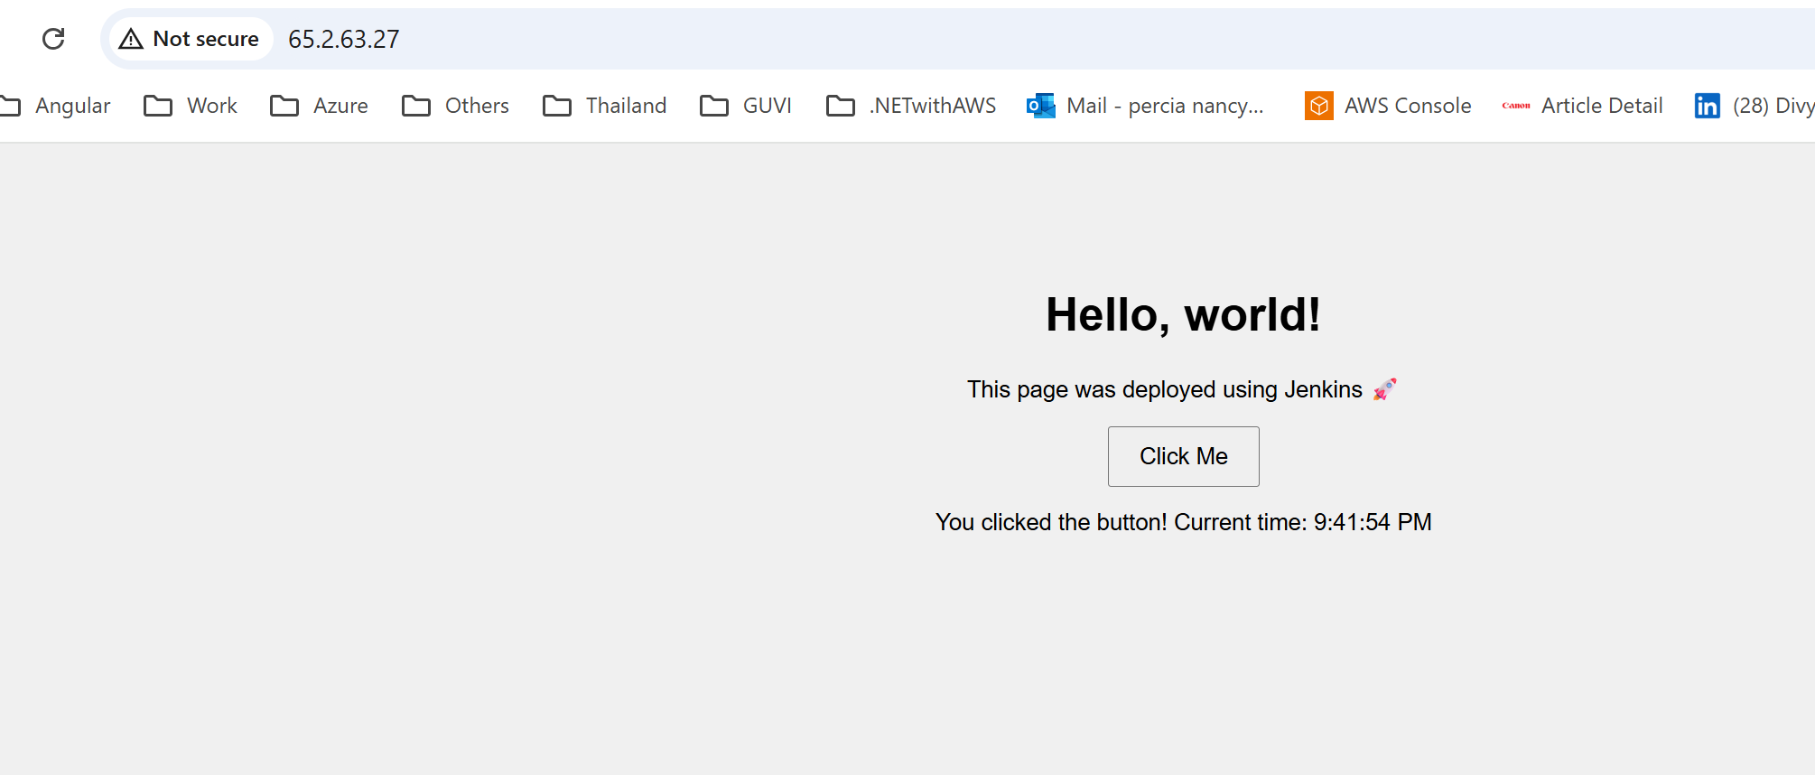

1. **Once the latest code pushed to GIT, deployment started**

